----------

Student 1

Name: Sayyid Iskandar Khan

Student number: 6959751

Email address: sisoa078@uowmail.edu.au

Assignment number: 2

Student 2

Name: Viswanadham Udaya Chitanya Krishna

Student number: 7083270

Email address: uckv235@uowmail.edu.au

Assignment number: 2

----------

**Files included in this assignment submission:**

**PHP Files**

1) index.php - the home page of our application

2) literature.php - this page comprises of the literature quiz with three different sections

3) math.php - this page comprises of the math quiz questions with three different sections

4) quizoutcome.php - the results page with overall score

**CSS File**

9) css/main.css - css styling common to all the pages

10) css/flex.css - css styling which helps to dynamically adjust sizing of boxes

11) css/tableui.css - css styling for tables used in the pages

**Description of pages for the assignment:**

**1. Index.php**The homepage of our application. The home page holds a basic login function that captures the user name to login and start participating in the quiz as well as displaying the user name while displaying the overall score of the user. The styling was minimal and had a white and blue colour theme following throughout the web application.



Image1.1: Homepage



Image1.2: Quiz selection page

Quiz selection page:

After the user enters the name and logins, users will be prompted with options to choose the quiz they want to attend. After choosing, I will be directed to the quiz questions.

**2. literature.php**

The literature.php page has quiz questions based on the books and their authors with three different sections. Each section consists of four different questions.

Functionality:

This page is packed with many featured navigation options beginning with a section navigator to jump from one section to another. A table element which comprises the questions and empty fields to answer along with a submit button to validate and check through the correct answers.

A line of informative elements displaying correct, incorrect, overall and current section score. Last but not least the back and next buttons to navigate from each section as well as option to navigate to Maths quiz from the current page as well as an Exit button to exit the quiz.

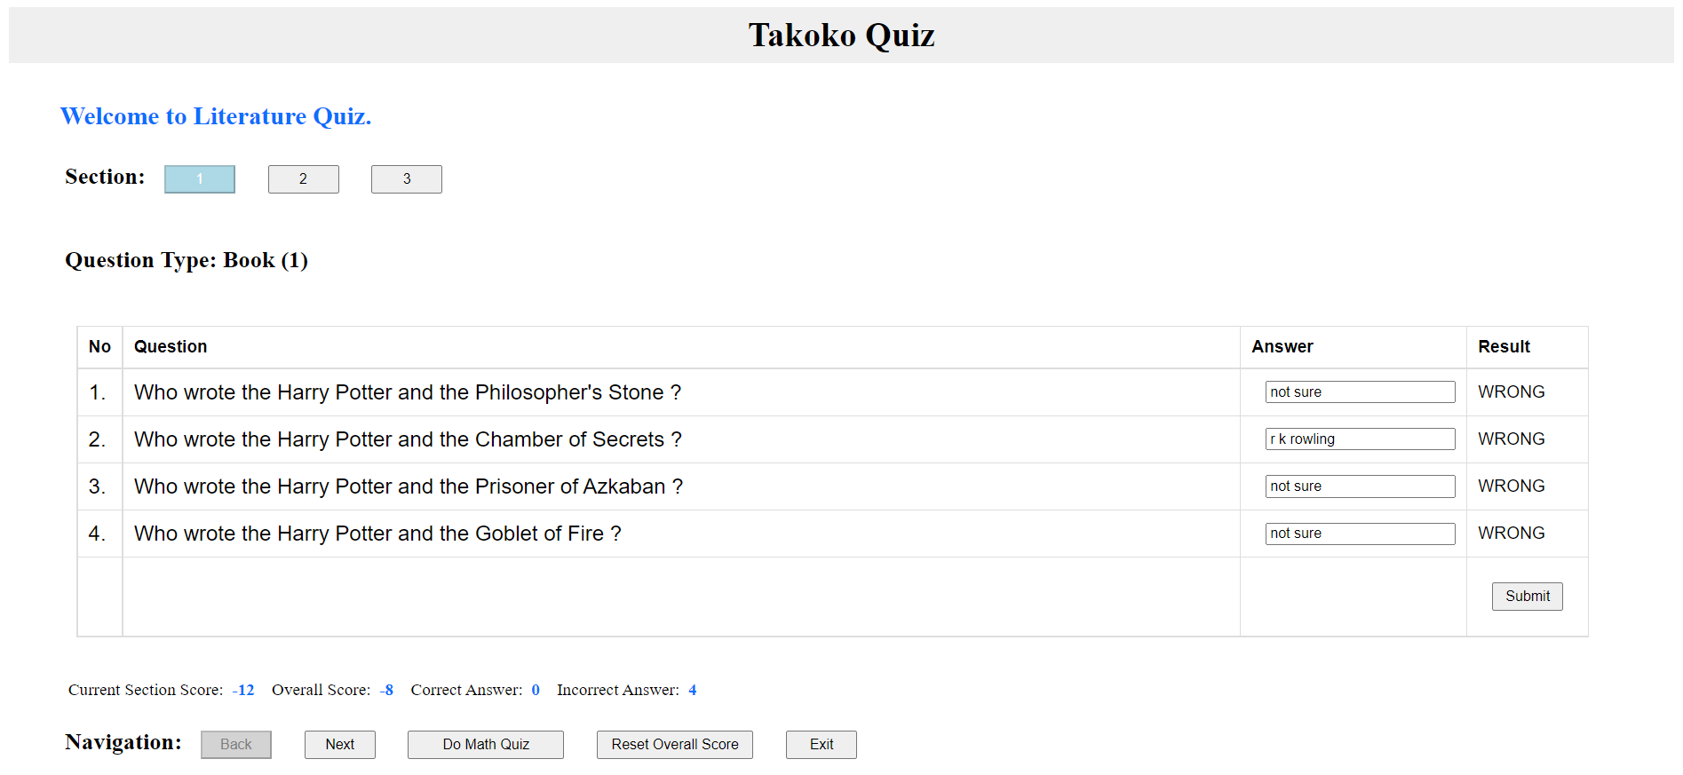

Image2: Literature quiz

**3. math.php**

The math.php page has quiz questions based on mathematics with three different sections ranging from addition, subtraction and multiplication & division questions in each section. Each section consists of four different questions with different operators.

Functionality:

Most of the functions are similar to that of literature quiz except the input fields with scrolling numbers to enter lets users enter small numbers while reaching for the keyboard.

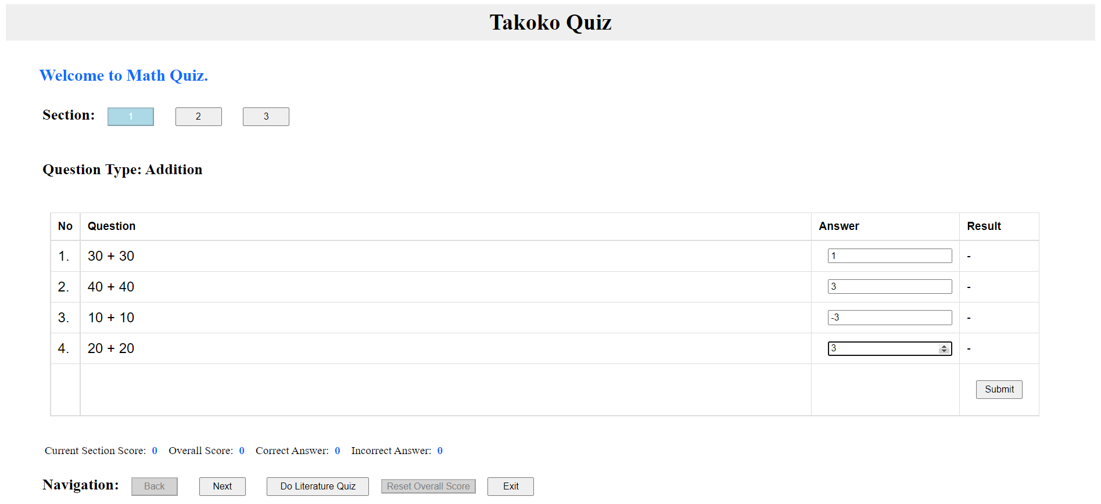

Image3: math quiz

**4. quizoutcome.php**

Exiting the application by pressing the exit button in the quiz section will bring the user to this outcome page to see the overall score.

Functionality:

The outcome page is greeted with an encouraging message with username and his score to let the user try again and again and provide options to choose the quiz.

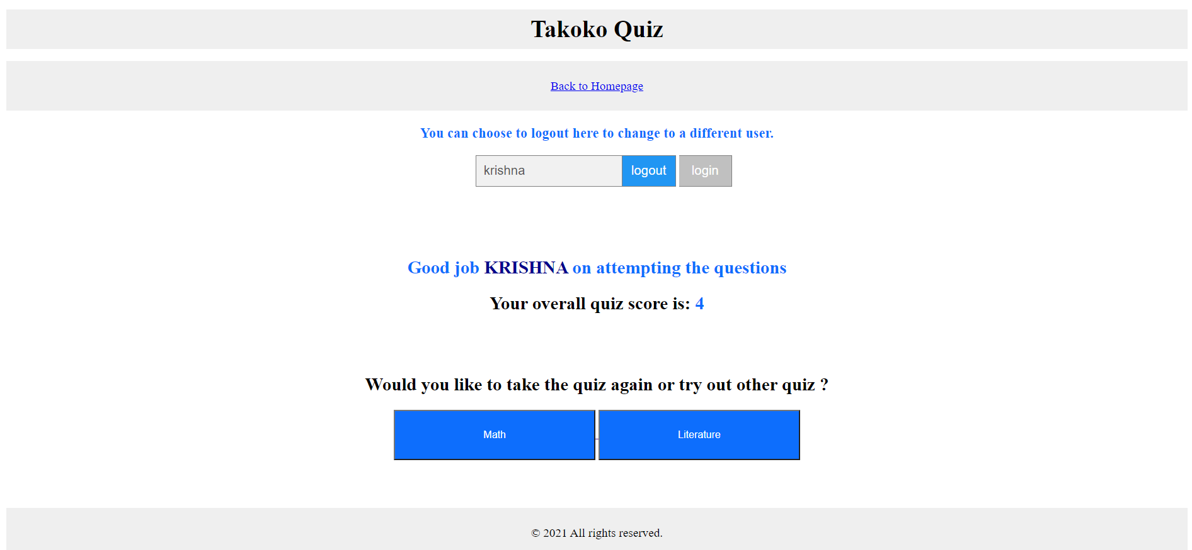

Image4.1: overall score

Logging out:

When the user logs out the user will be directed to this page to change the user or an option to go to the homepage which will redirect to the mainpage of the application.



Image4.2: logout page